
Assignment 10

Name : Aditya Latke
PRN : 1262252462
DIV : 1

PROBLEM STATEMENT:
Write a program in C to simulate a simple calculator that performs basic arithmetic operations such as addition, subtraction, multiplication, and division. The calculator should also perform special operations like computing xʸ (power) and x! (factorial).

OBJECTIVE:
• To understand the use of switch-case statements in C.
• To perform basic arithmetic and special mathematical operations.
• To enhance problem-solving skills using menu-driven programs.

THEORY:
A calculator is a basic computing device used to perform arithmetic operations. In C programming, a simple calculator can be implemented using conditional or switch-case statements. Arithmetic operations like addition, subtraction, multiplication, and division are fundamental operations. Special operations such as power (xʸ) and factorial (x!) require loops for repeated calculations.

PLATFORM:

Linux

ALGORITHM:
- Start
- Display menu of operations: +, -, *, /, xʸ, x!
- Input user's choice
- If choice is 0, exit program
- If choice is 1 to 4, input two numbers and perform the respective arithmetic operation
- If choice is 5, input base and exponent, compute power(base, exponent)
- If choice is 6, input number and compute factorial if number ≥ 0
- Display the result
- Repeat from step 2 until user chooses 0
- End

C PROGRAM:
#include <stdio.h>

// Function to calculate factorial
long long factorial(int n) {
long long fact = 1;
for (int i = 1; i <= n; i++)
fact *= i;
return fact;
}

// Function to calculate power
double power(double base, int exp) {
double result = 1;
for (int i = 1; i <= exp; i++)
result *= base;
return result;
}

int main() {
int choice;
double num1, num2, result;
int n;

do {
// Display menu
printf("\n--- Simple Calculator ---\n");
printf("1. Addition (+)\n");
printf("2. Subtraction (-)\n");
printf("3. Multiplication (*)\n");
printf("4. Division (/)\n");
printf("5. Power (x^y)\n");
printf("6. Factorial (x!)\n");
printf("0. Exit\n");
printf("Enter your choice: ");
scanf("%d", &choice);

switch(choice) {
case 1: // Addition
printf("Enter two numbers: ");
scanf("%lf %lf", &num1, &num2);
result = num1 + num2;
printf("Result: %.2lf\n", result);
break;
case 2: // Subtraction
printf("Enter two numbers: ");
scanf("%lf %lf", &num1, &num2);
result = num1 - num2;
printf("Result: %.2lf\n", result);
break;
case 3: // Multiplication
printf("Enter two numbers: ");
scanf("%lf %lf", &num1, &num2);
result = num1 * num2;
printf("Result: %.2lf\n", result);
break;
case 4: // Division
printf("Enter two numbers: ");
scanf("%lf %lf", &num1, &num2);
if (num2 != 0) {
result = num1 / num2;
printf("Result: %.2lf\n", result);
} else {
printf("Error: Division by zero!\n");
}
break;
case 5: // Power
printf("Enter base and exponent: ");
scanf("%lf %d", &num1, &n);
result = power(num1, n);
printf("Result: %.2lf\n", result);
break;
case 6: // Factorial
printf("Enter a number: ");
scanf("%d", &n);
if (n >= 0) {
printf("Result: %lld\n", factorial(n));
} else {
printf("Error: Factorial of negative number not possible!\n");
}
break;
case 0:
printf("Exiting Calculator.\n");
break;
default:
printf("Invalid choice!\n");
}

} while (choice != 0);

return 0;
}

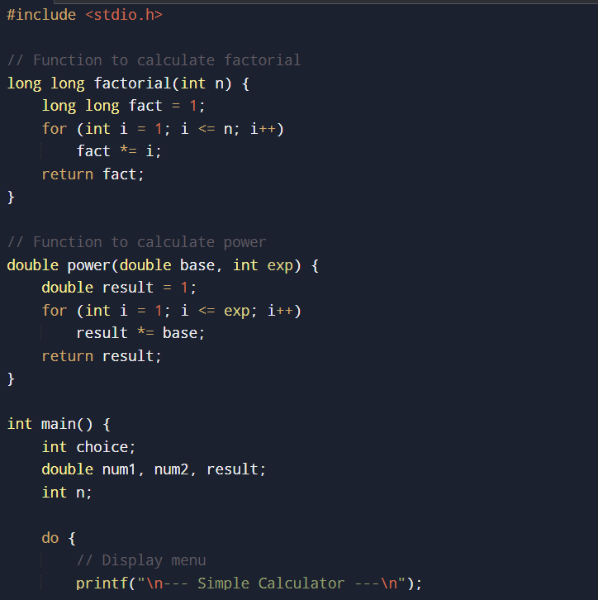
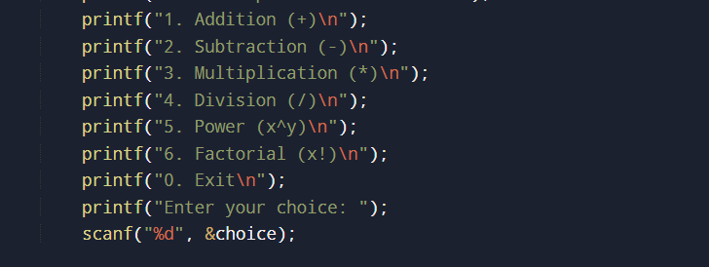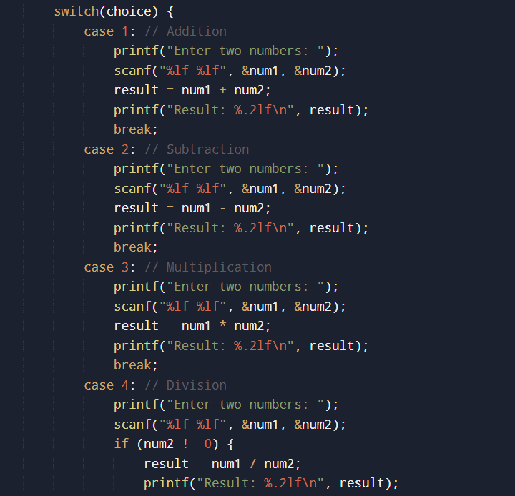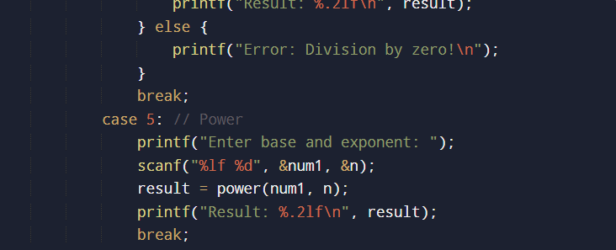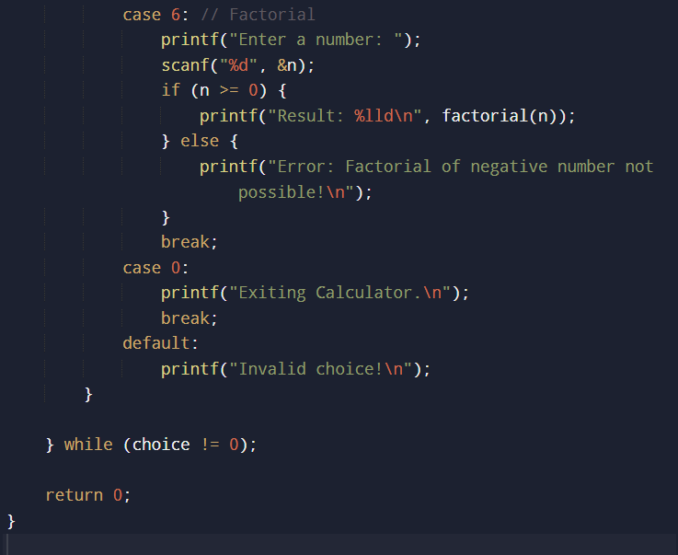

INPUT:
--- Simple Calculator ---
1. Addition (+)
2. Subtraction (-)
3. Multiplication (*)
4. Division (/)
5. Power (x^y)
6. Factorial (x!)
0. Exit
Enter your choice: 6
Enter a number: 7
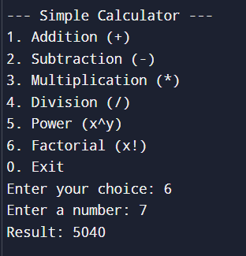

OUTPUT:
Result: 5040


CONCLUSION:
Thus, a simple calculator program was successfully implemented using C programming. The program demonstrates the use of switch-case statements, loops, and arithmetic operations.

FAQs:
1. What is a simple calculator program?
2. Why is switch–case preferred in calculator programs?
3. How does the program handle division by zero?
4. How is the power operation (xʸ) implemented without using math library functions?
5. What is factorial and how is it calculated using loops in C?

